1. Go to google search
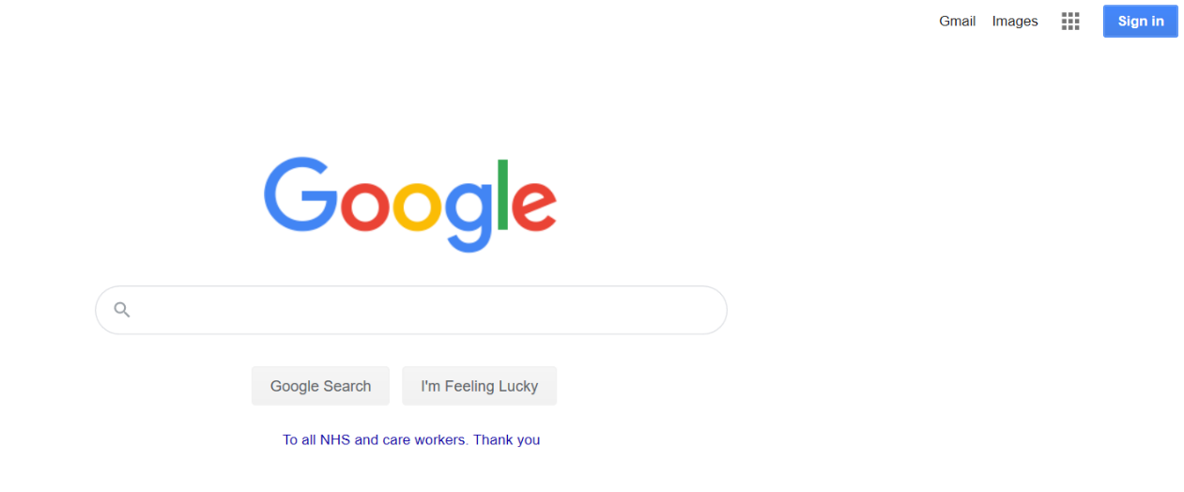

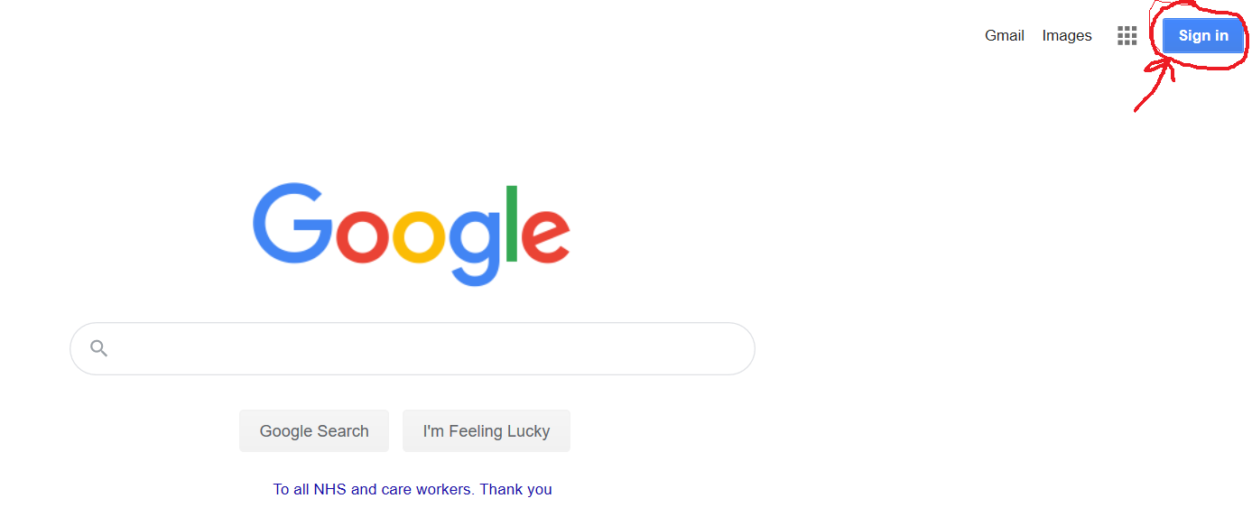
2. In the top right corner, find the ‘sign in’ button and click on it.

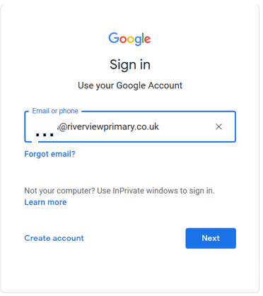
3. Next, you will have to log in using your logins and password (which are inside your child’s reading diary and click ‘Next’

4. This will take you to RM Unify platform, where you need to use your login and password again. Click ‘Sign in’.
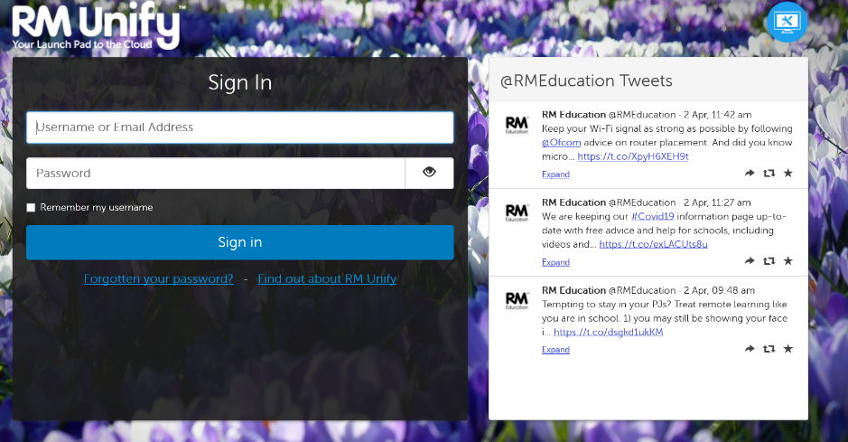

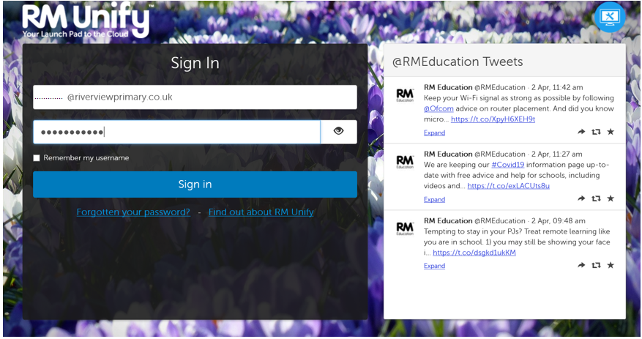

5. That will take you back to Google search, but this time you will be logged in. Check the icon in the top, right corner.

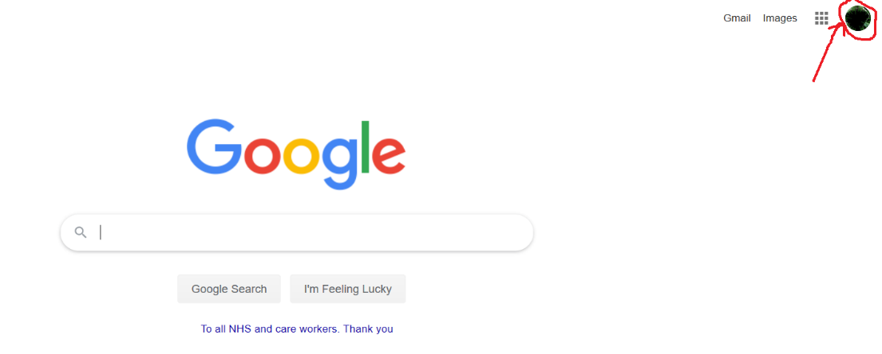

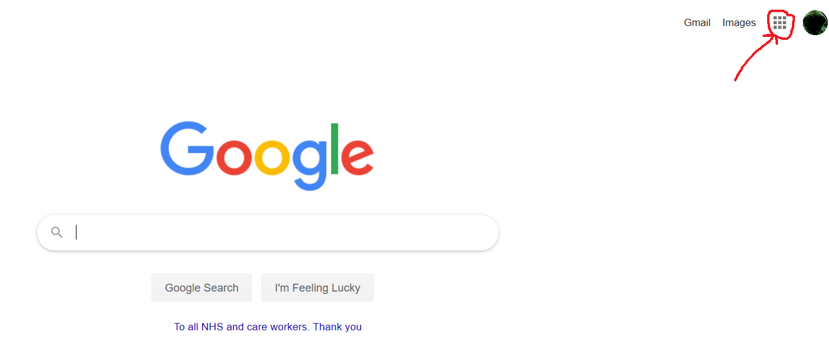
6. Click on the little squares icon, look at the red arrow.

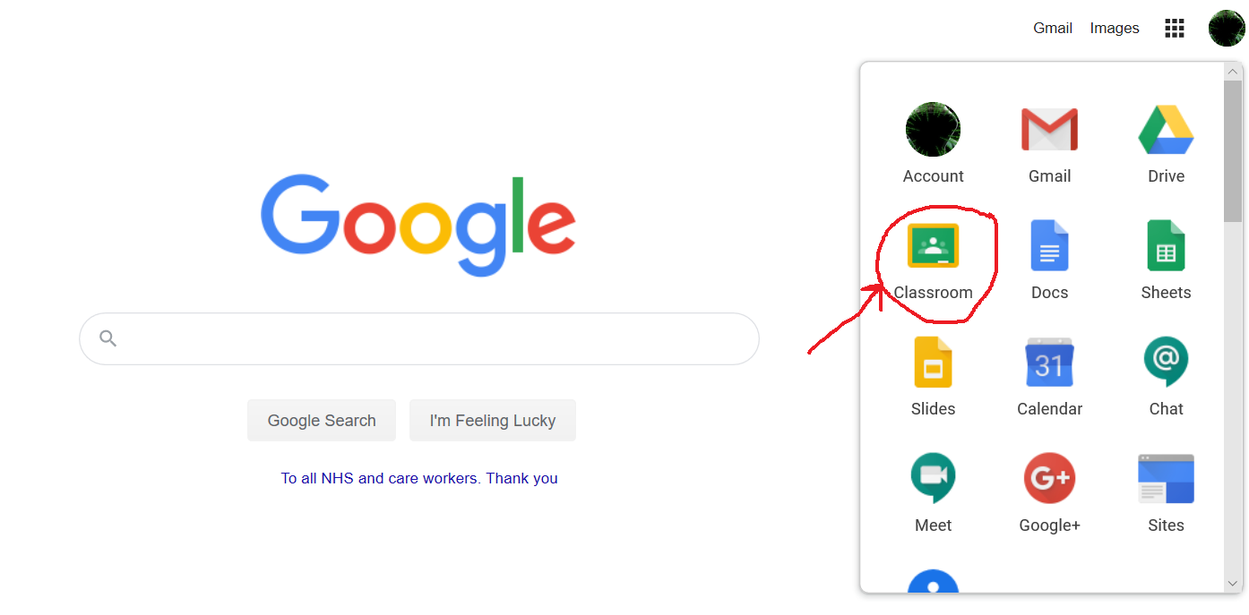
7. That will give you a few options, choose the classroom one as below.

8. That will take you to your classroom, if there are more than one option choose your class and your teacher.
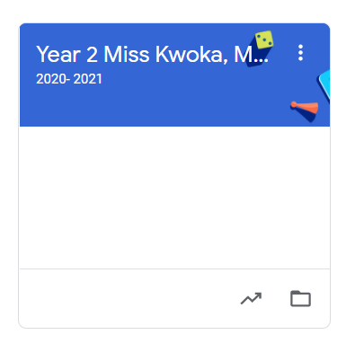

9. The last step is to take an active part in class life. You can see the assignments in the ‘classwork’ section. You can also see what has been done at school every day. Homework and announcements are also there.
